School of Computer Science
Carleton University

DisJ Cookbook (draft)
(DisJ version 1.1.0)

By: Rody Piyasin
Supervisor: Prof. Nicola Santoro and Prof. Doron Nussbaum

Revision Date: February 10, 2011

Table and Contents

Table and Contents 2
Chapter 1. Overview 3
Chapter 2. Preliminaries 4
Chapter 3. Createing a Topology 7
Chapter 4. Creaeting a Protocol 28
Chapter 5. Running a Simulation 37
Chapter 6. Graphical and satistic report 46
Chapter 7. Conclusion 49
Appendix 50

Chapter 1. Overview

This cookbook is a step-by-step description of the process of entering, executing and testing a reactive distributed algorithm using DisJ. It also describes how to use DisJ to simulate the algorithm and display the results in graphical interactive.

Here are four simple steps for using DisJ.
- Install DisJ plug-in into Eclipse
- Define a topology in DisJ graph editor
- Write a protocol in Java language in Eclipse JDT
- Execute the protocol in the defined topology using DisJ

Throughout the cookbook we will use two an example protocols; first protocol is “As Far” that represent message passing model for leader election in a ring with bidirectional links network, and second protocol is “Agent Traversing” that represent mobile agent with token model for counting number of nodes in a ring with bidirectional link network (see Appendix)

Chapter 2. Preliminaries

2.1 Install Eclipse

The DisJ is an Eclipse™ plug-in, therefore we need to have Eclipse™ (version 3.0 or higher) installed. Eclipse is an open platform built by an open source community, which it can be downloaded at http://www.eclipse.org/downloads/. There are many types of builds available, but we recommend “Eclipse Classic” or “Eclipse IDE for Java Developer”.

2.2 Install GEF libraries

Since DisJ graphical interface parts built on top of Graphical Editor Framework Plug-in (GEF), therefore, DisJ plug-in requires GEF Plug-in to be installed. GEF runtime library can be downloaded at http://www.eclipse.org/gef/downloads/index.php. There are many types of packages release, but we recommend “All-In-One” that includes Draw 2D, GEF and Zest.

2.3 Install DisJ

The installation of DisJ is similar to any others Eclipse Plug-ins by unzip the file and place the folder “org.carleton.scs.disJ_1.1.0” into ECLIPSE_HOME/plugins folder.

To make sure that the plug-in was successfully installed, restart Eclipse™. Go to the menu Help → About Eclipse SDK

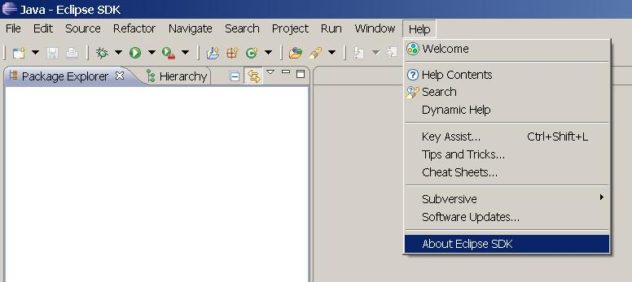

Then a dialog box shown below must pop up on the screen

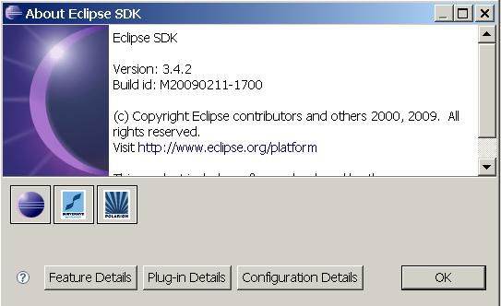

Then click on “Plug-in Details” button and a dialog with list of current installed plug-ins of the Eclipse will be listed which included “DisJ Simulator” (if the installation has been done correctly) as shown in the picture below.

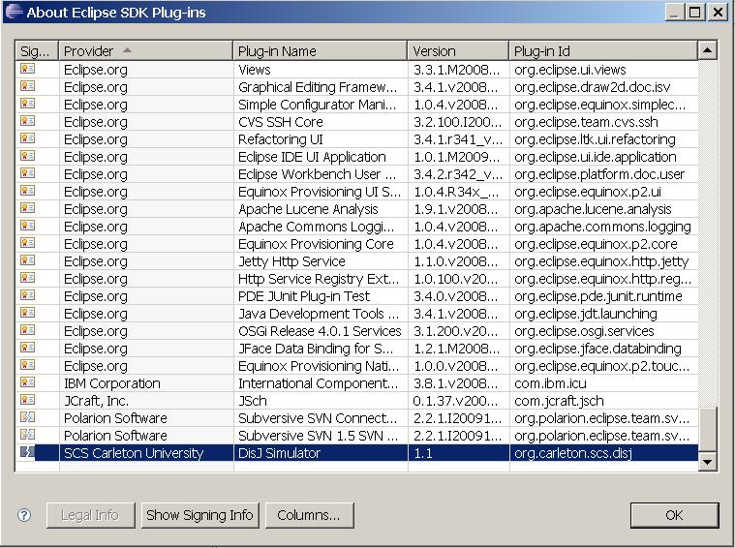

Note that any Plug-ins that has been installed into Eclipse successfully, the name of the Plug-ins will be listed in this dialog box, which include our GEF Plug-ins as well. Therefore, this is a good place to check and verify installed Plug-ins in your Eclipse.

2.4 Changing Perspective

After Eclipse has started a workbench is opened; the workbench can be viewed from many different perspectives; the default one is the “Resource Perspective”. Since we are going to develop the distributed algorithm in Java™ it is better to switch to the “Java Perspective”. This will automatically forces user to follow the rules and best practices in software development with Java.

Click at icon at a top of your right hand to the list of available perspectives (as shown below).

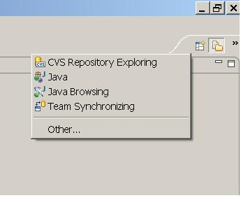

Then select Java perspective as shown below

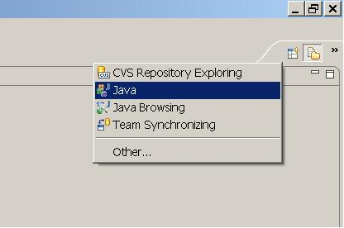

Chapter 3. Creating a Topology

3.1 Creating a Java project

For a best practice in software development, we need to create a Java Project first by right click at “Package Explorer” view, then select New → Java Project

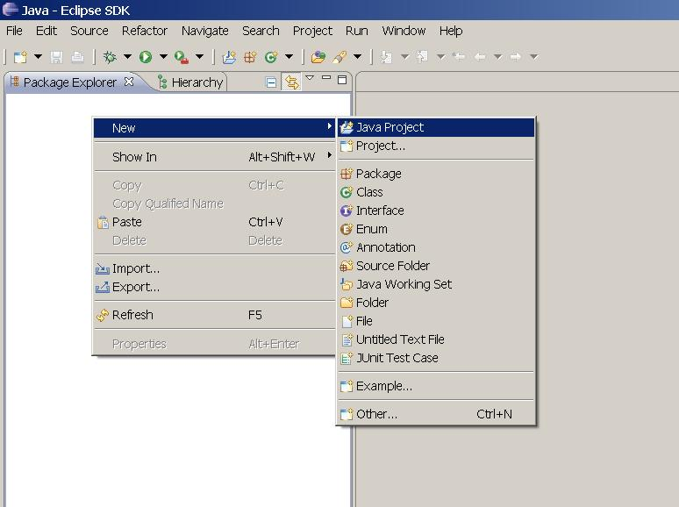

The project creation wizard dialog box will pop up as below and type the project name in lower case (for a best practice)

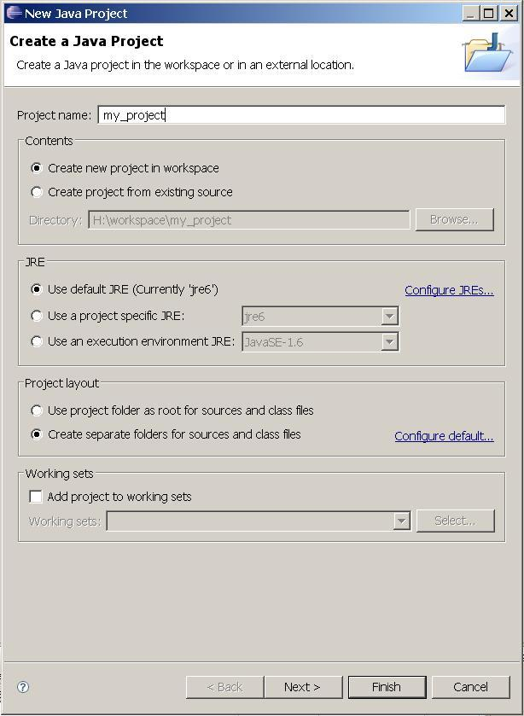

Leave the default setting as it is then click Next → select Libraries tab

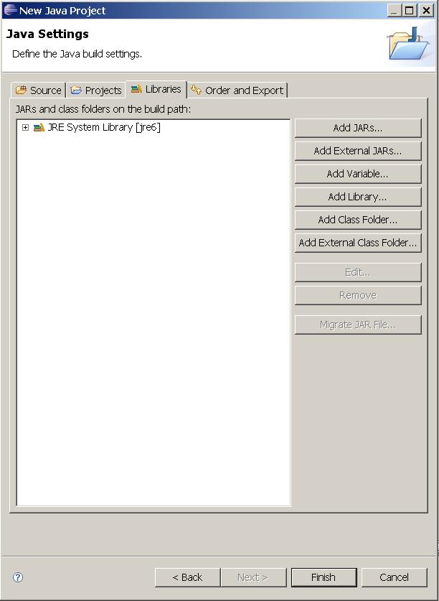

In order to add “DisJ” runtime libraries and API for developing algorithm. So we will add “disJ.jar” which located at ECLIPSE_HOME/plugins/org.carleton.scs.disj_1.1.0/ by clicking at “Add External JARs…” button and select disJ.jar from above said location. The dialog box will look like the following. Then click “Finish” button.

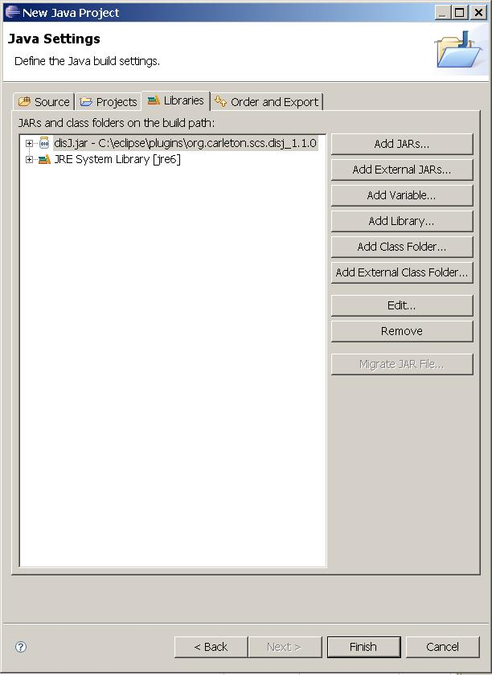

The workbench under Java Perspective will look like the following.

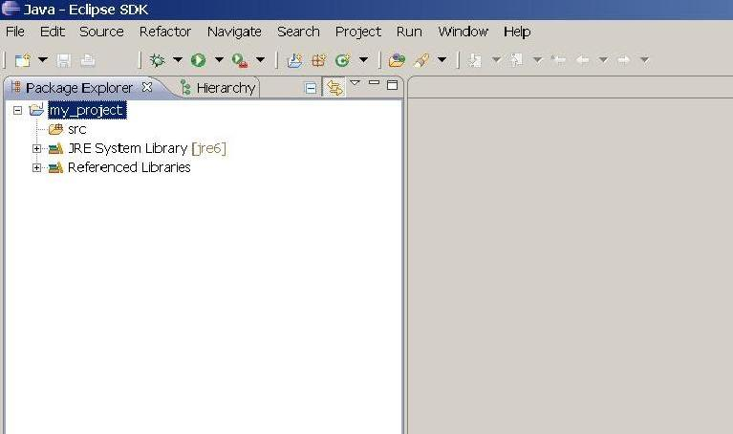

3.2 Creating a Graph File (.gph)

Right click at our Java Project in “Package Explorer”, and select “New→ File” (see below);

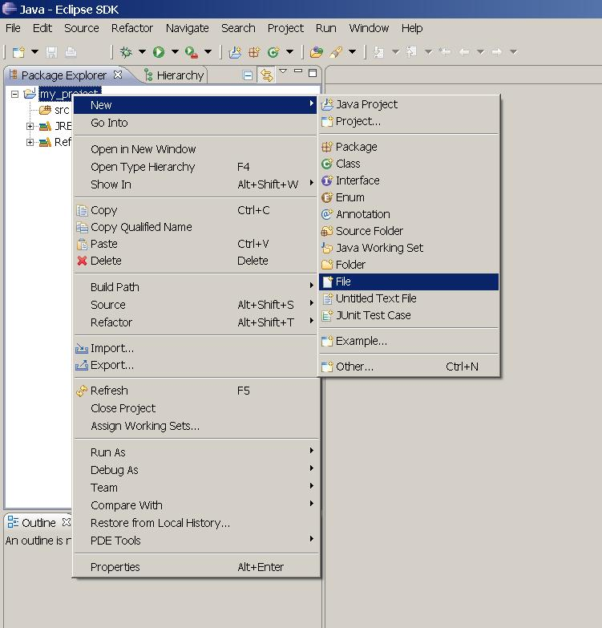

The a file creation dialog pop up as shown below, then fill up a file name with extension file type “.gph”

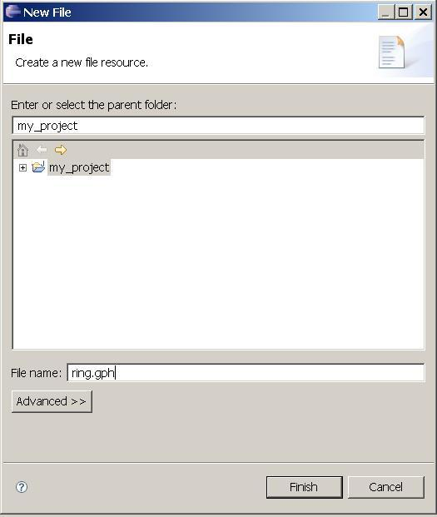

Then click “Finish”.

The workbench will look like the following

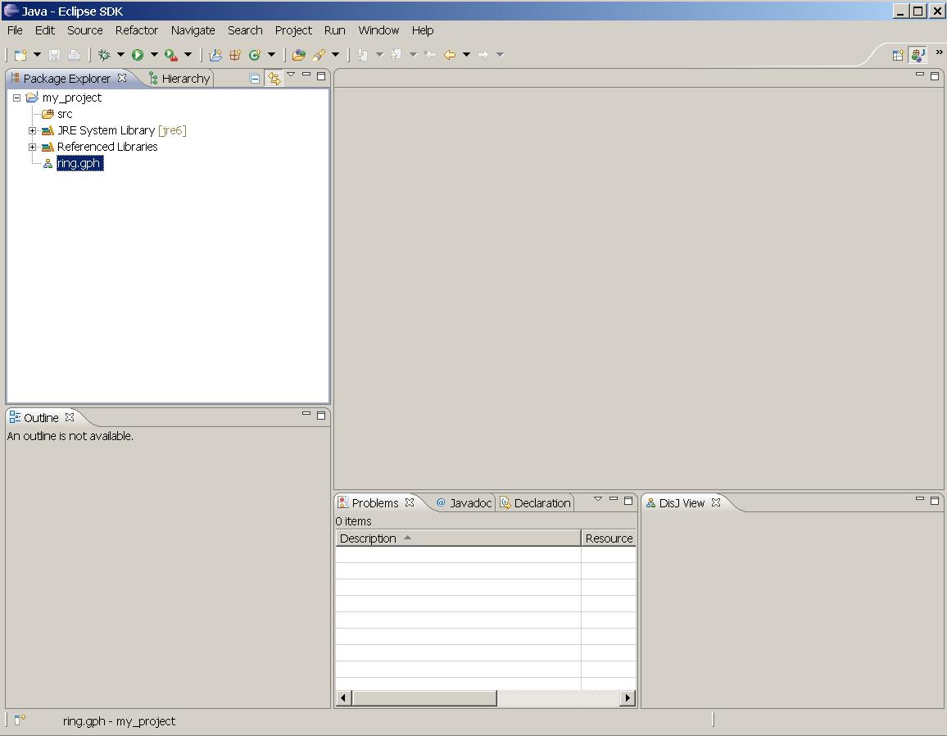

Then double click our new graph file, ring.gph, which will open up “DisJ Graph Editor” into the workbench and look like the following

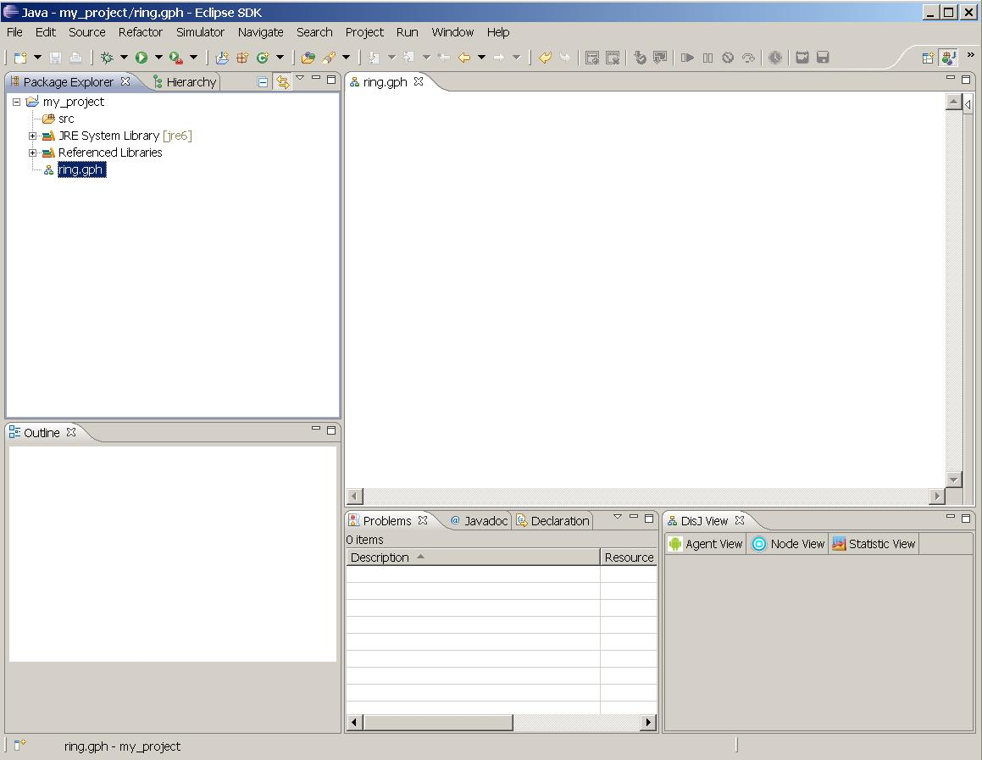

3.3 Creating a graph in DisJ Graph Editor

The DisJ Graph Editor shows up on the editor view. We start drawing by expanding the “Palette” on a top right corner of the editor tab by clicking at icon

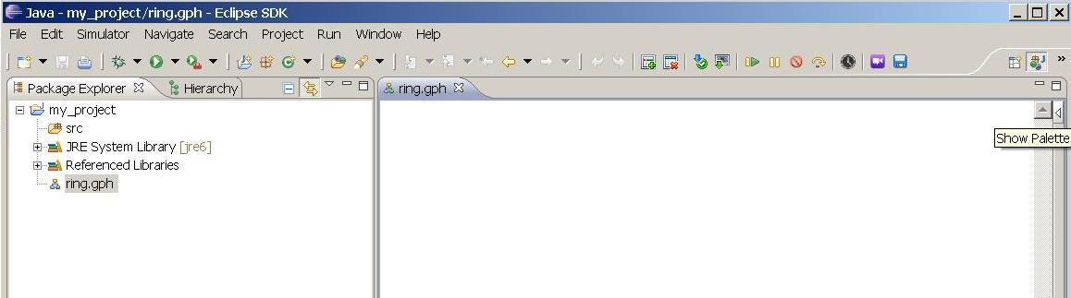

And it looks like the following

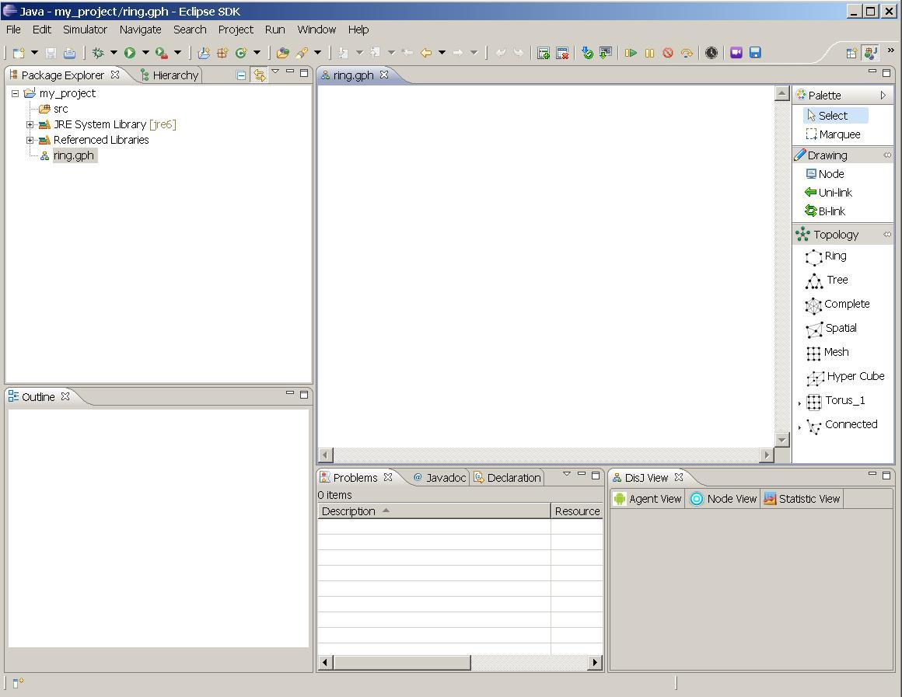

There are two ways to define a graph:

    - Draw - this is a basic drawing tool based on simple objects such as node, uni-directional link and bi-directional link.

    - Topology Library- this provides a ready-made set of topologies that can be edited such as Ring, Tree, Spatial, Complete, Mesh, Hyper Cube, Arbitrary and Torus.

Drawing the object on the editor is simple; as in other drawing applications, the user can choose to draw the objects manually from the drawing category or use a readymade draw from Topology Library.

Here is an example of defining a bidirectional Ring with 10 nodes using the Topology Library.

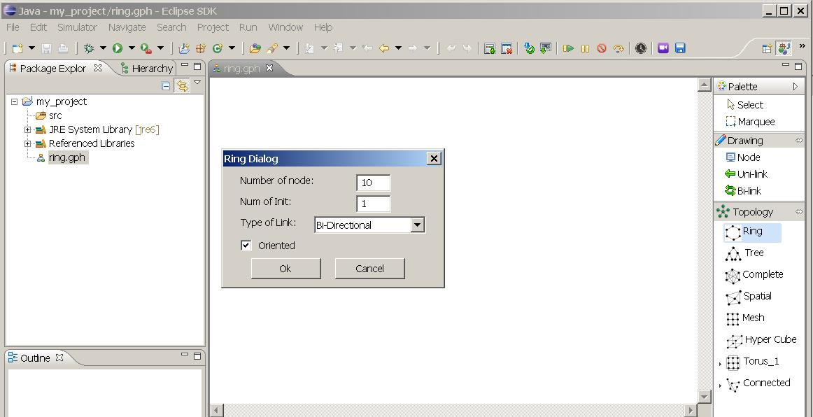

Here is the snapshot when a Ring of size 10 is created.

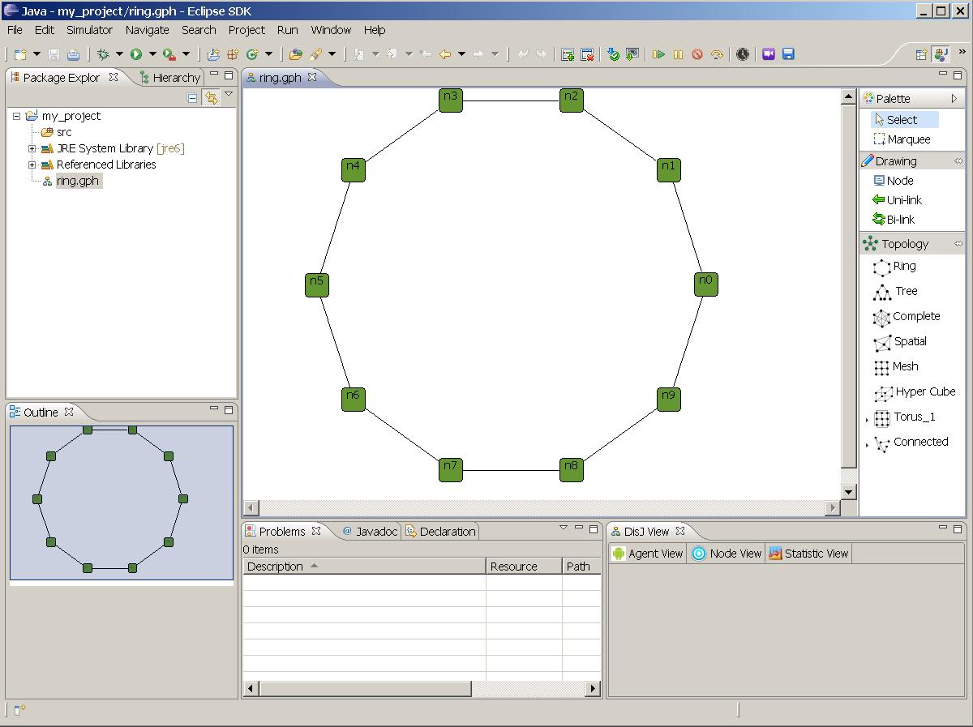

Once, the graph has been drawn, you can check if there is the correct number of links and nodes by opening a “Properties View” which will show the current states and properties. To open the “Properties View”, go to menu bar, select Window->Show View-> Properties; if it does not list, select Window->Show View->Others.

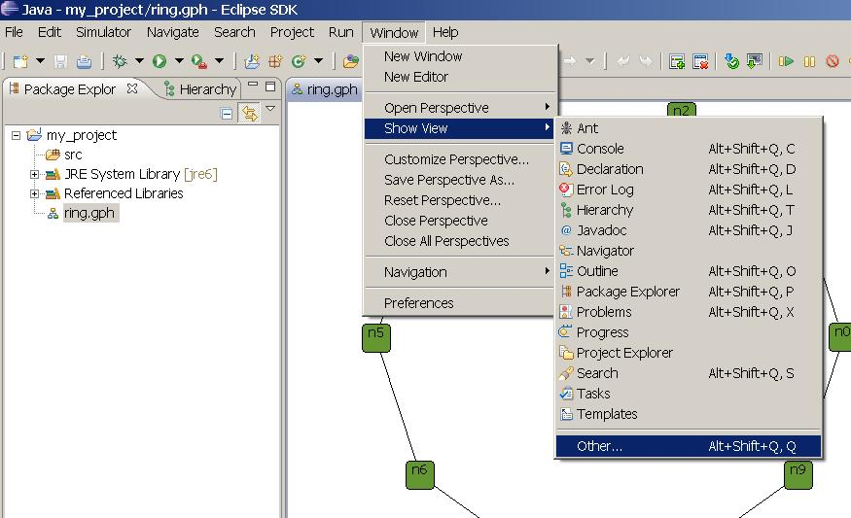

Once the dialog shows up, expand a “General” folder and select “Properties”.

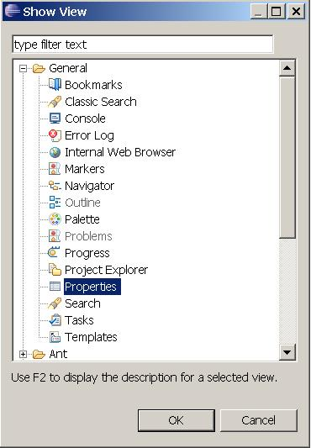

In addition to the graph properties; there are properties of the nodes and of the links. We will now describe them in some detail in later section, the following is snapshot of our workspace with properties view.

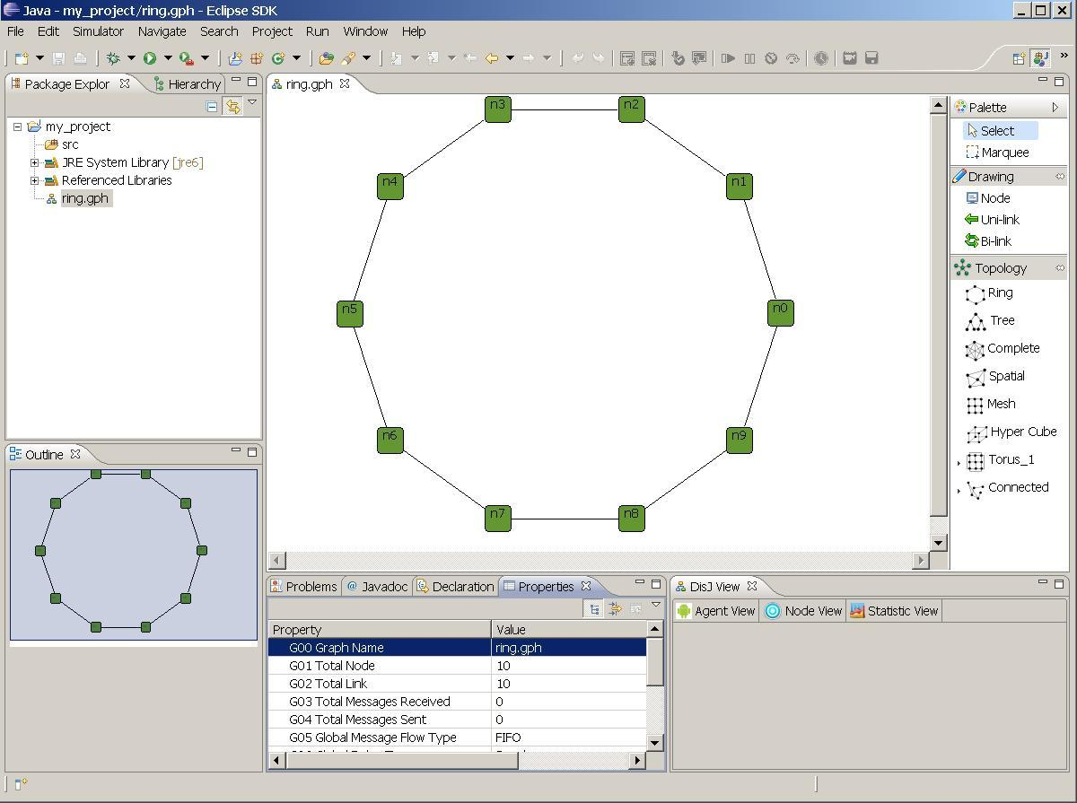

3.4 Element Properties

3.4.1 Graph Properties

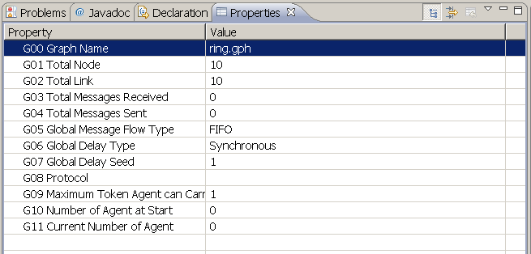

3.4.1.1 Graph Name (not editable)
This is the name of the file where the graph has been defined.

3.4.1.2 Total Node
Total number of nodes in this graph

3.4.1.3 Total Link
Total number of links in this graph

3.4.1.4 Total Messages Received
Total number of messages that have been received from the start of the execution of the protocol upto now

3.4.1.5 Total Messages Sent
Total number of messages that have been sent from the start of the execution of the protocol upto now

3.4.1.6 Global Message Flow Type
Flow type of every links in this graph, there are 2 types, FIFO and No Order. If one or more link has difference type than others in the graph, this field will be set to “Mix Order”

3.4.1.7 Global Delay Type
Type of traveling delay of every links in this graph, there are 5 types, Synchronous, Random Uniformed, Random Poisson, Random Customs, Customs. If one or more link has difference type than others in the graph, this field will be set to “Custom”

3.4.1.8 Global Delay Seed
A number of simulation time unit required on each link in the graph. This value will be used only when the delay type is Synchronous. If one or more link has difference value than others in the graph, this field will be set to -1 (negative value)

3.4.1.9 Protocol
A name of protocol that currently being executed in this graph

3.4.1.10 Maximum Token Agent Can Carry
A maximum number of every agent in this graph can carry token. This will be used only in Agent with Token Model simulation

3.4.1.11 Number of Agents at Start
A number of agents exist in the graph at the beginning of simulation. This value will be used only in Agent with Token and Agent with Whiteboard Model simulations

3.4.1.12 Current Number of Agents
A number of agents currently exist. This value will be used only in Agent with Token and Agent with Whiteboard Model simulations

3.4.2 Node Properties

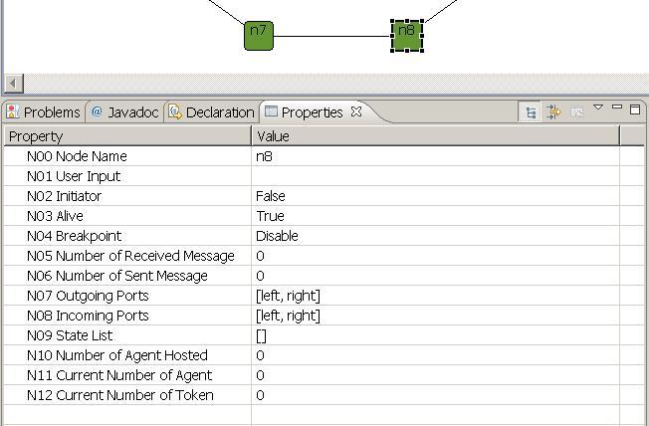

3.4.2.1 Node Name
A Name of selected node

3.4.2.2 User Input
Input text field that user can enter during executions of the simulation. The algorithm can retrieve this input via disJ API

3.4.2.3 Initiator
This property specifies whether the node is an initiator of the simulation execution. There must be at least one node in a graph to be an initiator in order to start the simulation. The only node with this property set to be True will execute function “distributed.plugin.runtime.enging.Entity.init()” in user code

3.4.2.4 Alive
This property reflect whether a node is alive (up and running) or death (crashed)

3.4.2.5 Breakpoint
This property is used for debugging purpose. Once a node’s breakpoint is enabled, the execution will be suspended as soon as a message/agent arrives at the node.

3.4.2.6 Number of Messages Received
Total number of messages that have been received by this node from the start of the execution of the protocol upto now

3.4.2.7 Number of Messages Sent
Total number of messages that have been sent by this node from the start of the execution of the protocol upto now

3.4.2.8 Outgoing Ports
A list of all outgoing ports available at this node

3.4.2.9 Incoming Ports
A list of all incoming ports available at this node

3.4.2.10 States Transition
This property reports the sequence of states transition of the node that has been changed from the start of the simulation until now

3.4.2.11 Number of Agent Hosted
Total number of agents that this node hosted has “Home Base” from the beginning of the simulation. This is used with Agent with Whiteboard and Agent with Token models only

3.4.2.12 Current Number of Agents
Total number of agents currently resides at this node. This is used with Agent with Whiteboard and Agent with Token models only

3.4.2.13 Current Number of Tokens
Total number of Tokens currently resides at this node. This is used with Agent with Whiteboard and Agent with Token models only

3.4.3 Link Properties

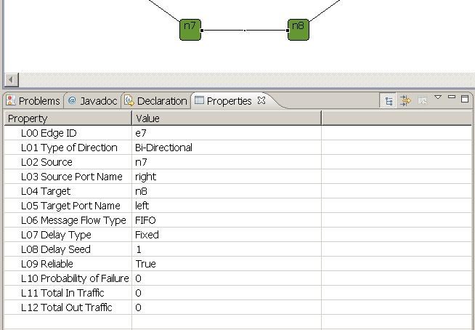

3.4.3.1 Edge ID
An ID of selected link

3.4.3.2 Type of Direction
The type of communication link

3.4.3.3 Source Name
The source node’s name of the link

3.4.3.4 Source Port Name
The source port’s name of the link

3.4.3.5 Target Name
The target node’s name of the link

3.4.3.6 Target Port Name
The target port’s name of the link

3.4.3.7 Message Flow Type
This property specifies the flow type of messages inside the link. There are only two types: FIFO and No Order.

3.4.3.8 Delay Type
Type of traveling delay of every links in this graph, there are 5 types, Synchronous, Random Uniformed, Random Poisson, Random Customs, Customs

3.4.3.9 Delay Seed
A number of simulation time unit required on each link in the graph. This value will be used only when the delay type is Synchronous

3.4.3.10 Reliable
This property is for verifying the reliability of a link; if it is True no message will be lost, else it will be lost with uniformly distributed random with probably that set in “Probability of Failure”.

3.4.3.11 Probability of Failure
This property specifies the probability rate that a message will fail on this link, if a Reliable of the link is set to “False”.

3.4.3.12 Total In Traffic
Total number of messages/agents entering into this link

3.4.3.13 Total Out Traffic
Total number of messages/agents departing from this link

3.5 Difference type of Topologies

DisJ Graph Editor provides a Topology Library that offers a set of readymade graphs

3.5.1 Ring Graph

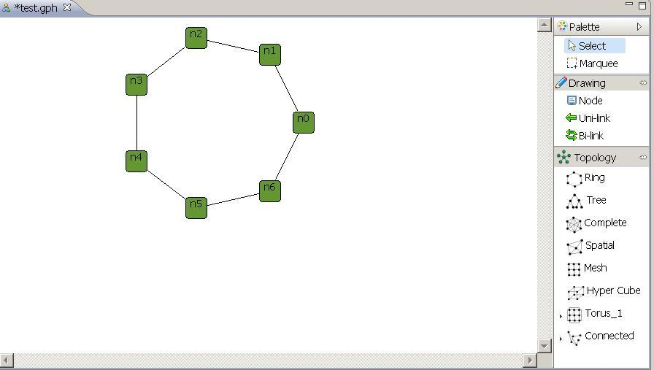

3.5.2 Tree Graph

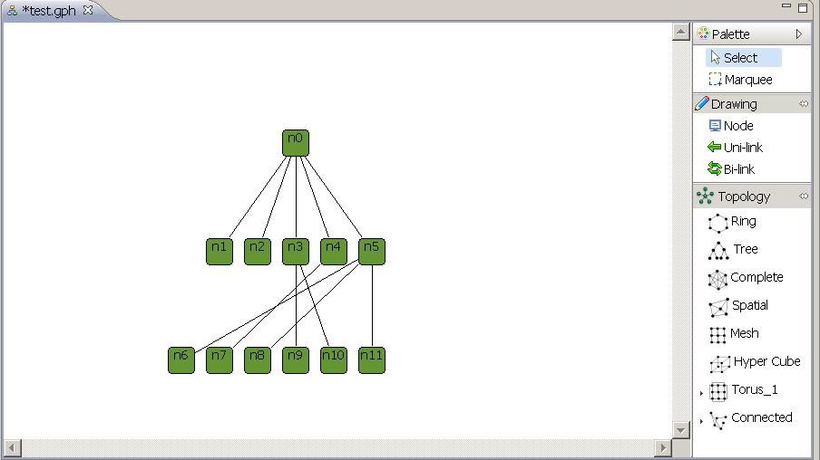

3.5.3 Complete Graph

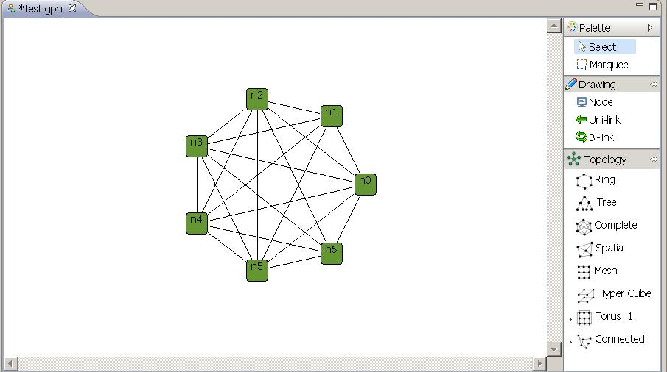

3.5.4 Spatial Graph

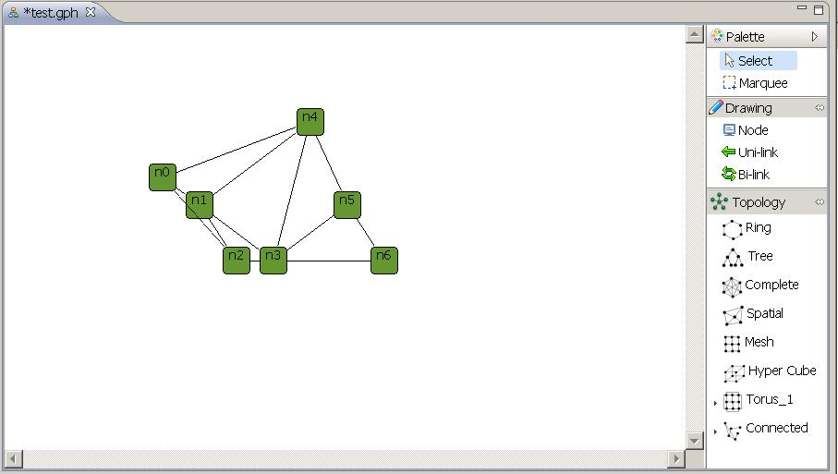

3.5.5 Mesh Graph

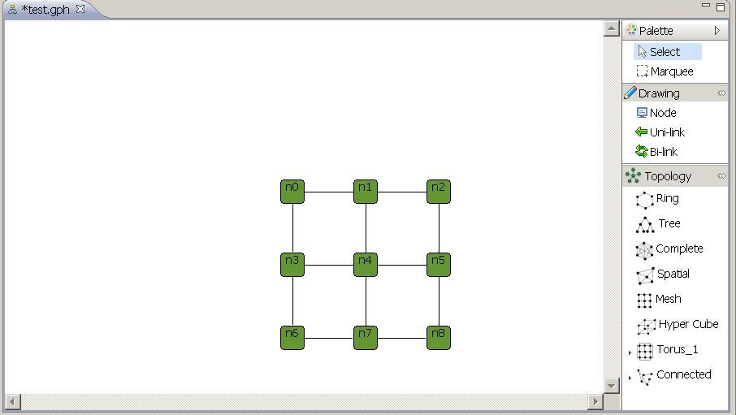

3.5.6 Mesh Graph

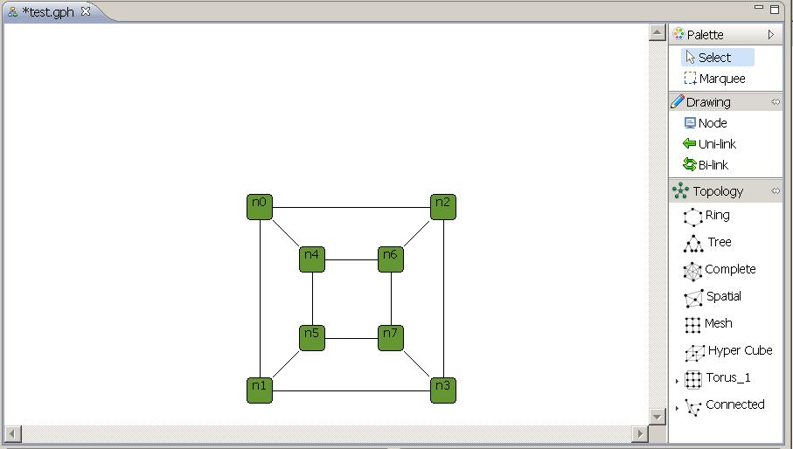

3.5.7 Torus Graph

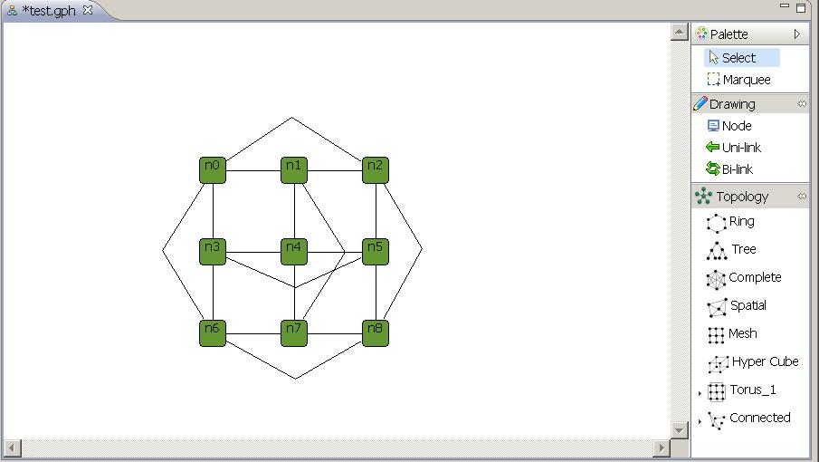

3.5.8 Random Connected Graph

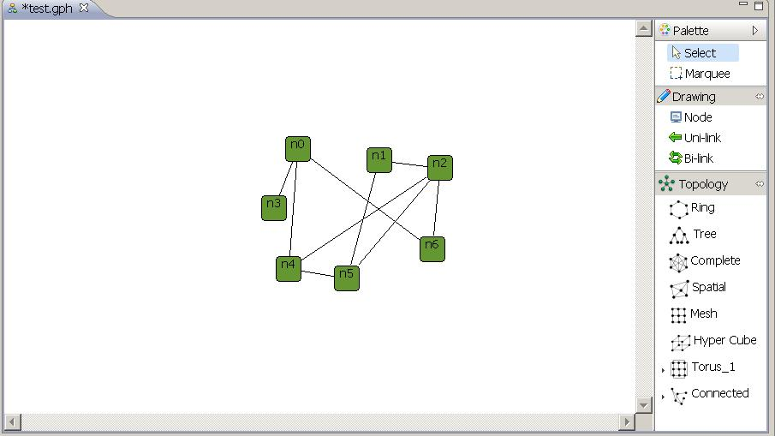

3.5.9 Random Forest Graph

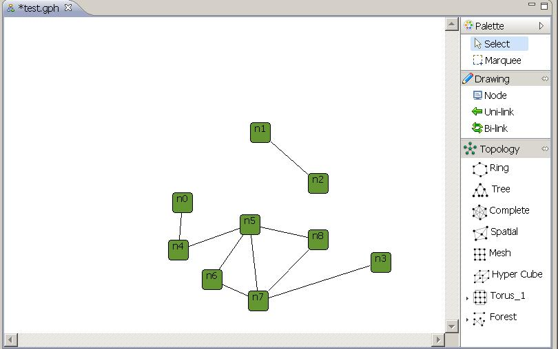

3.5.10 Summary

A user can create a graph by using a basic Draw objects or using Topology Library that provide a common readymade graph. Once a graph is created, there are some points about property setting and modifying a graph that user must keep in mind.

A graph that created by Topology Library can be modified like add/remove node(s) or link(s), adjust location of displaying nodes or links, also user can mix all different types of topologies into one graph and save it as a single file.

Chapter 4 Creating a Protocol

4.1 Creating a Protocol File (Java Class)

Creating a protocol is the same as creating Java class and file, which we will have to follow best practices by first creating package by “Right Click” at “src” under our project folder then select New→ Package as shown below

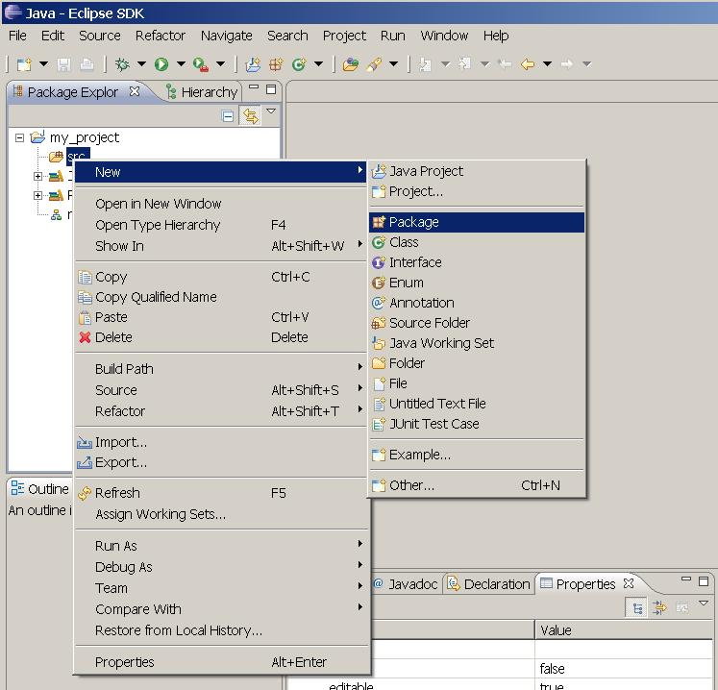
The dialog will pop up, then type in a package name in lowercase i.e. my_test as shown below, then click “Finish button”

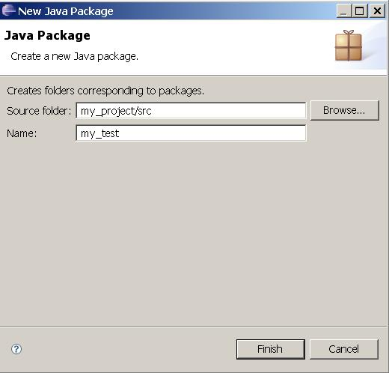

The package name we just created will be appeared under “src” folder. Now, create a new Java class by “Right Click” at “my_test” package, then select New → Class as show below

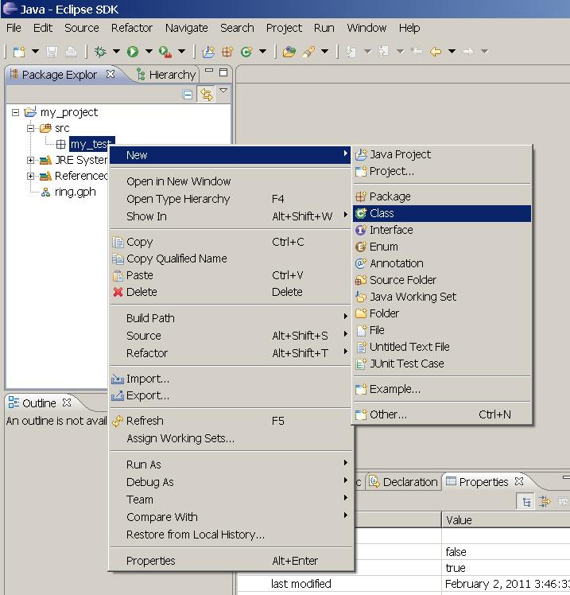

A file creation dialog will pop up, then type in a Java Class name i.e. AsFar. Since AsFar is a protocol for Message Passing Model, therefore the supperclass is “distributed.plugin.runtim.engine.Entity”, click at “Browes” button to find and select our supper class (see Chapter4.2) then “check” the checkbox “Constructor from superclass” and click “Finish” button

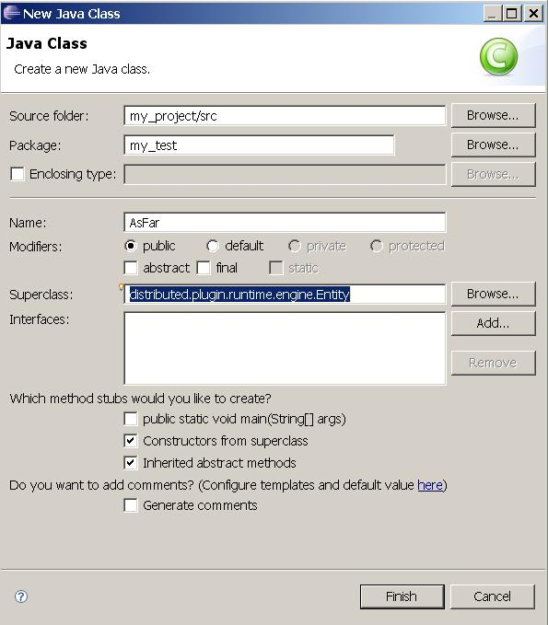

The workbench will be looked like as follow

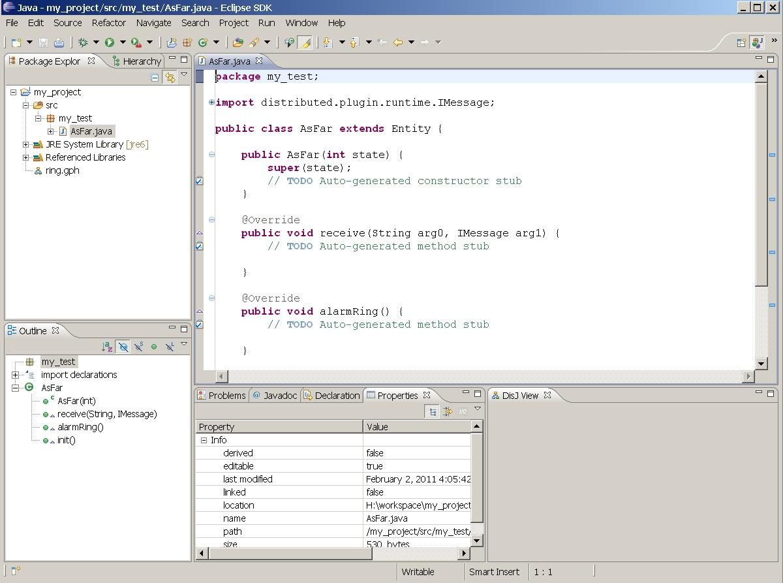

4.2 Rules and Conventions.

DisJ provides three types of distributed computing models and each has it own supperclass for user to inherit as follow

- Message Passing Model → “distributed.plugin.runtime.engine.Entity”

- Agent with Whiteboard Model → “distributed.plugin.runtime.engine.BoardAgent”

- Agent with Token Model → “distributed.plugin.runtime.engine.TokenAgent”

Therefore, a user class has to inherit one of these superclasses based on the model, and it will be an entry point class for DisJ simulator to run the simulation of user protocol.

There are some conventions for writing a distributed algorithm with DisJ that user has to follow.

    - The entry class of the protocol MUST extends one of above superclasses based on the model that user are working on and creates an EMPTY parameter Constructor(default Constructor). This class does not need “public static void main(String[])” (even if the user has one it will never be called)

    - State for Entity in distributed protocol must be “public static final int” or “public final int” and the name of the state must begin with “state” or “_state” which the cases are insensitive

    - Assign an initial state to an entity by passing a state value into “super(int initState)” inside the default constructor created in 4.2.1

    - User should NOT invoke any DisJ API inside the constructor, since the entity object has not yet been created

    - There are three methods that user class has inherited from superclass, Entity, of Message Passing Model and user might need to implement

public void init():this method is invoked on a node if and only if the node property “Initiator” is set to be True (see Chapter 3.4.2.3)

public void alarmRing(): this method is invoked when an internal alarm clock of a node is rang. The alarm time can be set at a node by invoking method setAlarm(int countDown)(see Chapter 4.2.10)

public void receive(String inPortLabel, IMessage msg):this method is invoked when a node receives a message. This method is a main message processing functions of node algorithm

    - There are four methods that user class has inherited from superclass, TokenAgent, of Agent Token Model, and BoardAgent of Agent Whiteboard Model and user might need to implement

public void init():this method is invoked on a node if and only if the node property “Initiator” is set to be True (see Chapter 3.4.2.3)

public void alarmRing(): this method is invoked when an internal alarm clock of a node is rang. The alarm time can be set at a node by invoking method setAlarm(int countDown)(see Chapter 4.2.10)

public void arrived(String viaPortLabel):this method is invoked when an agent arrived at a node. This method is a main action processing functions of agent algorithm

public void notified(NotifyType type):this method is invoked when there is registered action happening at a node where an agent currently resides and registered. This method is a function that will activate agent that waiting something to happen at the node to continue its process. In order to register event at a node, agent must call method registerHostEvent(NotifyType) at current resides node with preferred type of event, the register will be removed automatically when the agent leave the node. There are four NotifyType as follow

- AGENT_ARRIVAL: Activate when any agent arrived at this node
- AGENT_DEPARTURE: Activate when any agent leave this node
- TOKEN_UPDATE: Activate when number of token at this node has been changed
- BOARD_UPDATE: Activate when whiteboard of this node has been modified

    - DisJ library has provided standard programming interfaces (API) for user to access communication and infrastructure libraries for his/her reactive distributed algorithms. The following are examples of common and useful API that can be used in the algorithm

Message Passing Model
sendTo()
become()
getState()
getName()
getInPorts()
getOutPorts()

Agent with Token Model
moveTo()
become()
getAgentId()
getNodeId()
getState()
getNodeState()
getInPorts()
getOutPorts()
countHostToken()
countMyToken()
dropToken()
pickupToken()

Agent with Board Model
moveTo()
become()
getAgentId()
getNodeId()
getState()
getNodeState()
getInPorts()
getOutPorts()
readFromBoard()
removeFromBoard()
appendToBoard

For full list of available APIs can be found at DisJ Java API Documents or using code assist from Eclipse IDE.

4.3 Coding a Protocol

The convention for distributed algorithm in DisJ is based on reactive model defined in state x event → action (see Appendix)

This section will discuss how to convert “state-event” driven pseudo algorithm to “even-state” driven in Java algorithm. In order to make it easy to understand we will write a protocol for Ring Election named “As Far” with multiple initiators, unique ID, bidirectional links, synchronous, and total reliable environment.

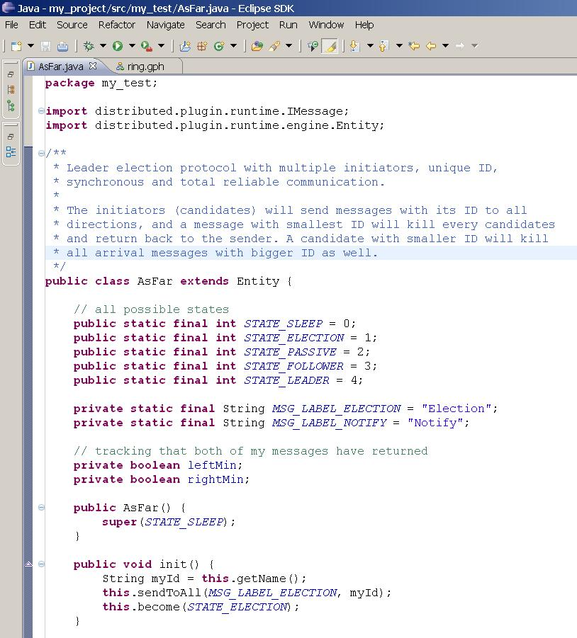

Here an example of implementing Entity.receive() method

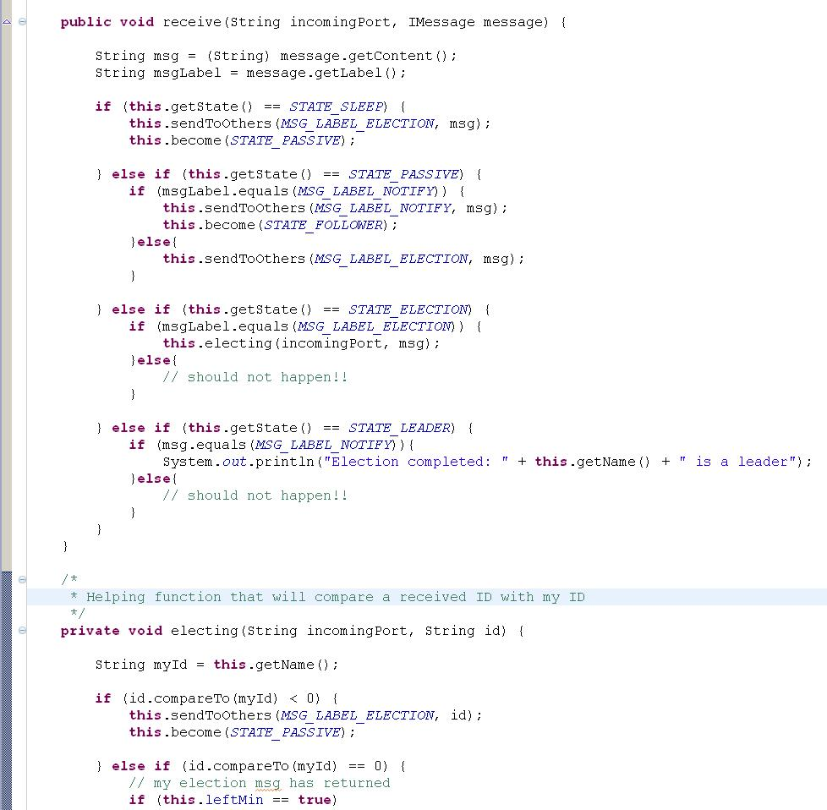

Some inherited function that the protocol does not need, user can leave it empty as function Entity.alarmRing()as shown below

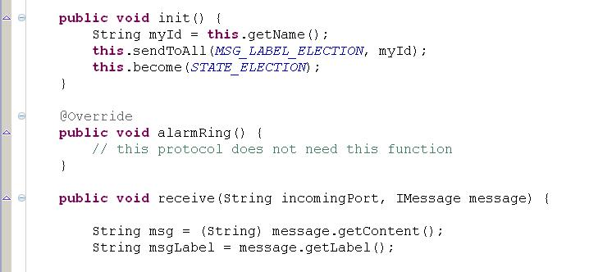

4.4 Setting State Color

In order to see real-time nodes state update in DisJ Graph Editor during the simulation; the user must specify a color for each state that defined in the protocol (see Chapter 4.2.2) by set the workbench focus to DisJ Graph Editor, then go to menu bar, select Simulator→Add States as shown below

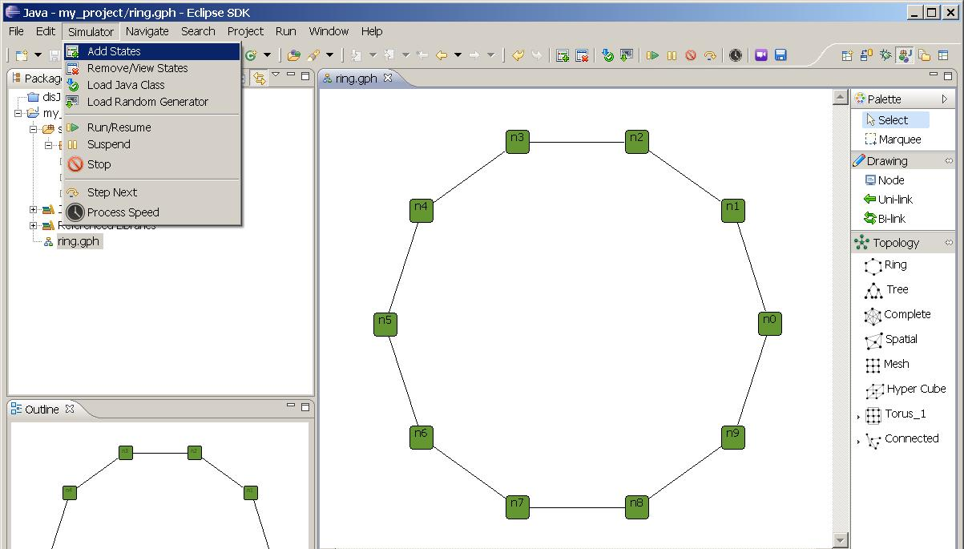

A dialog box shows up, give a value (number) that match to the state value in protocol and select the color from a “Color Palette”, the value will recorded in number-color pair; if a same state value are given twice, it will override the existing color. Once the graph is saved, the states of color will be saved along the graph.

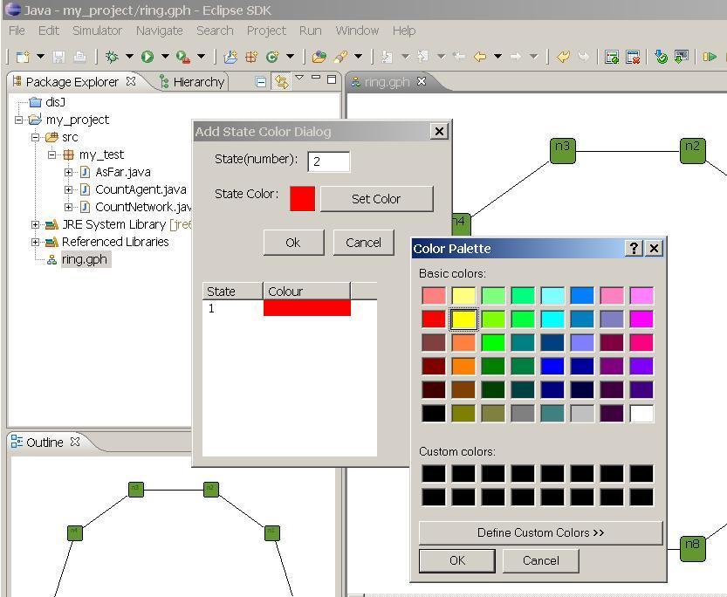

If the user wants to remove or see the list of state color pairs, go to menu Simulator→ Remove State; a dialog box will show a list of number-color pairs. To remove, check the checked box at a pair that wants to remove and click Remove as shown below.

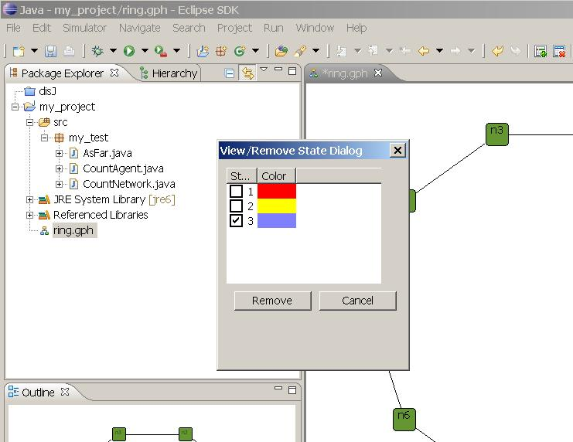

Note that the simulator will ignore all the number-color pairs that do not match the states declared in protocol. Therefore, only a match number- color pairs will be used during the simulation.

Chapter 5. Running a Simulation

There are few things that we have to know in order to run the simulator and it is described as follow.

5.1 Loading protocol into a Topology

Once topology(graph file) and protocol are created; To simulate the protocol in the simulator, user has to load the protocol into the topology by go to menu select Simulator→ Load Java Class as shown below

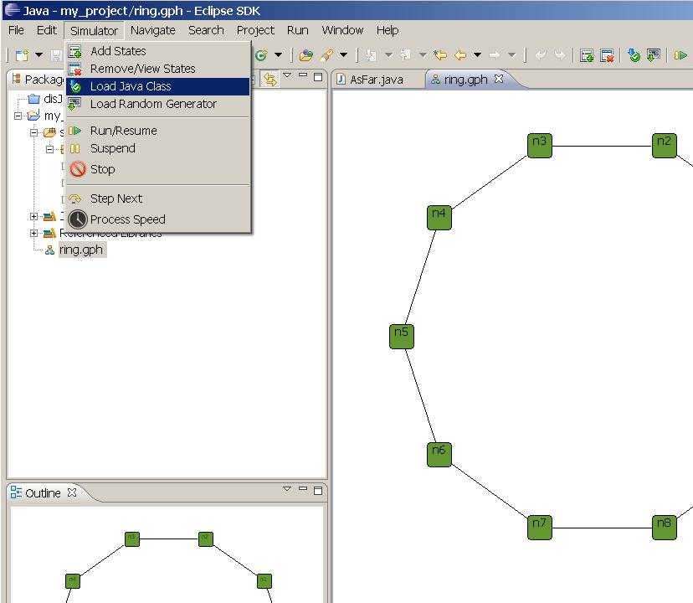

Once a dialog shows up; there are three models to select, in this example is Message Passing Model. Then type in a Fully Qualified Class Name of the entry class (a class that implement distributed.runtime.engine.Entity), in this example is “my_test.AsFar” (as show below) then click OK. Remember that all the protocol classes and the graph file (.gph) must be under a same project folder, in this example is “my_project”. Each graph file is independent from other graph file in a same project, means loading the entry class into one graph file does not affect other graph file.

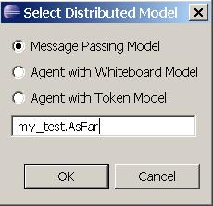

Important: If a protocol has been loaded into a graph file, then later on a .java file of the protocol has been modified, the graph file has to be closed and reopen again in order to reload a new modified Java source into the graph file.

5.2 Run/Resume the simulator
Once the class is loaded into the topology; then go to menu select Simulator→ Run/Resume, now DisJ is simulating the protocol. In order to simulate another protocol with a same topology, the user must reload a new protocol into the topology

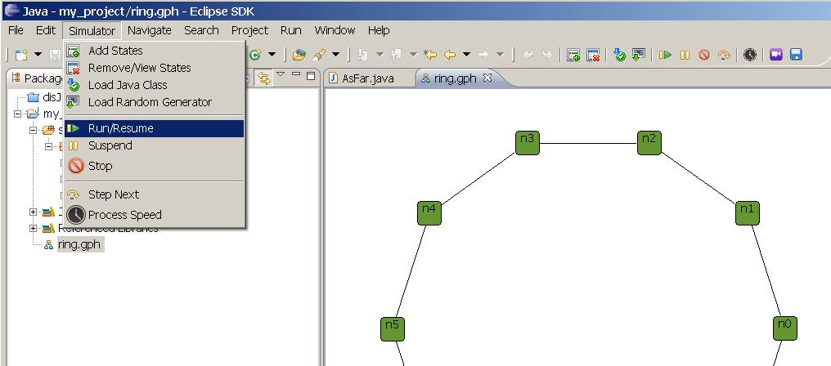

5.3 Stop the simulator
In order to stop the simulation, go to menu and select Simulator → Stop at anytime once the simulation is started. After the simulator stopped all the current states and information are wiped out. Therefore, the user cannot see any information in the “Properties View” anymore. Therefore, before rerun or run a new a simulation, user must make sure that the simulator is stopped

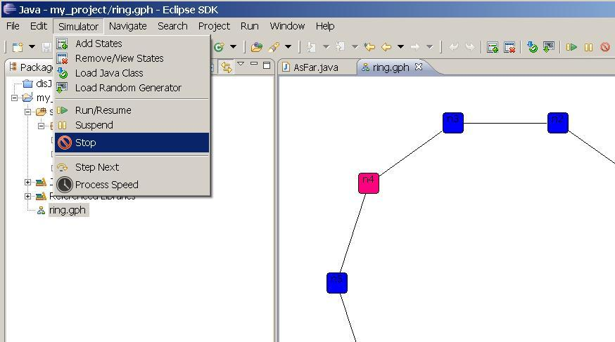

5.4 Suspend the simulator
In order to pause the simulation, go to menu and select Simulator → Suspend at anytime once the simulation is started, and to resume the execution by go to menu and select Simulator → Run/Resume as well. Remember that suspend does not wipe out the current states and information therefore, user can observe the current states in graph and “Properties View” as well.

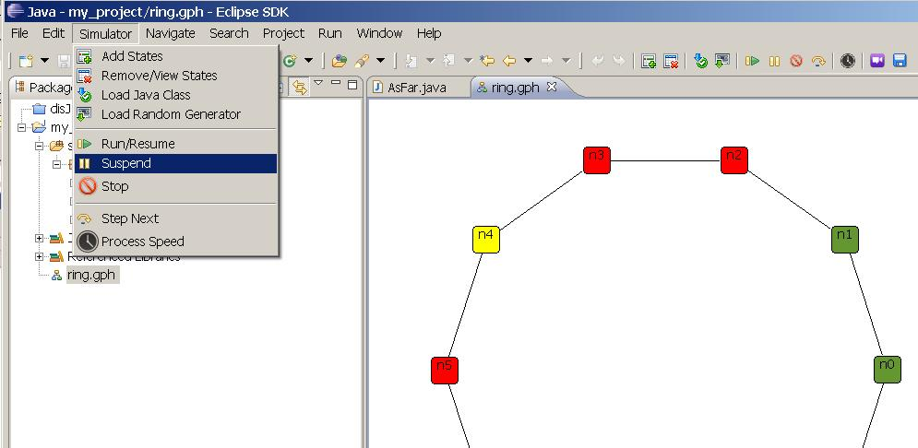

5.5 Step Next
This feature is not yet support.

5.6 Setting Processing Speed
This feature allows user to setup the speed of the processor in execution the protocol, by first the simulation MUST be suspended then go to menu and select Simulator → Process Speed and the process speed scale will show up and allow user to slide in order to adjust the current speed of this process as shown below

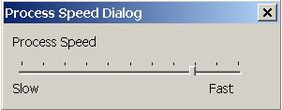

5.7 Replay Record
This feature allow user to replay the simulation that has been run based on a saved record file (.rec) Currently, every simulation will be saved automatically once the simulation is ended under the project/bin/ in this example is “…/my_project/bin”, the .rec file name will be a name of a topology (graph file .gph) e.g. ring.rec for this example. Therefore, the .rec file will be override automatically if the simulation has been run on a same graph file more than once, so, it is user responsibility to rename a .rec file if user willing to save the record file for further usage.

In order to replay, user select an icon and a File Open dialog will pop up, and then select a .rec file e.g. ring.rec. The replay will start immediately, and user may use suspend, resume, adjust speed and stop as if the simulation is running. Note that the results, statistic report and behavior of the replay is the exactly the same as what happening during the simulation of the record and cannot be edited.

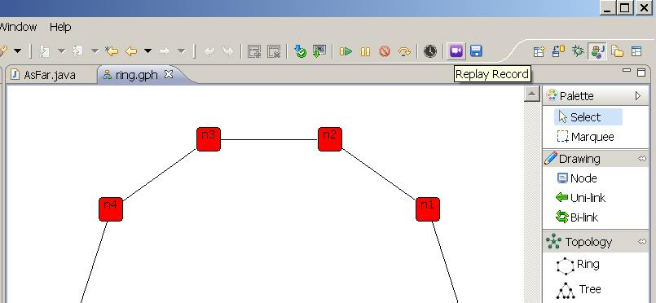

Here is a snap shot when DisJ is executing

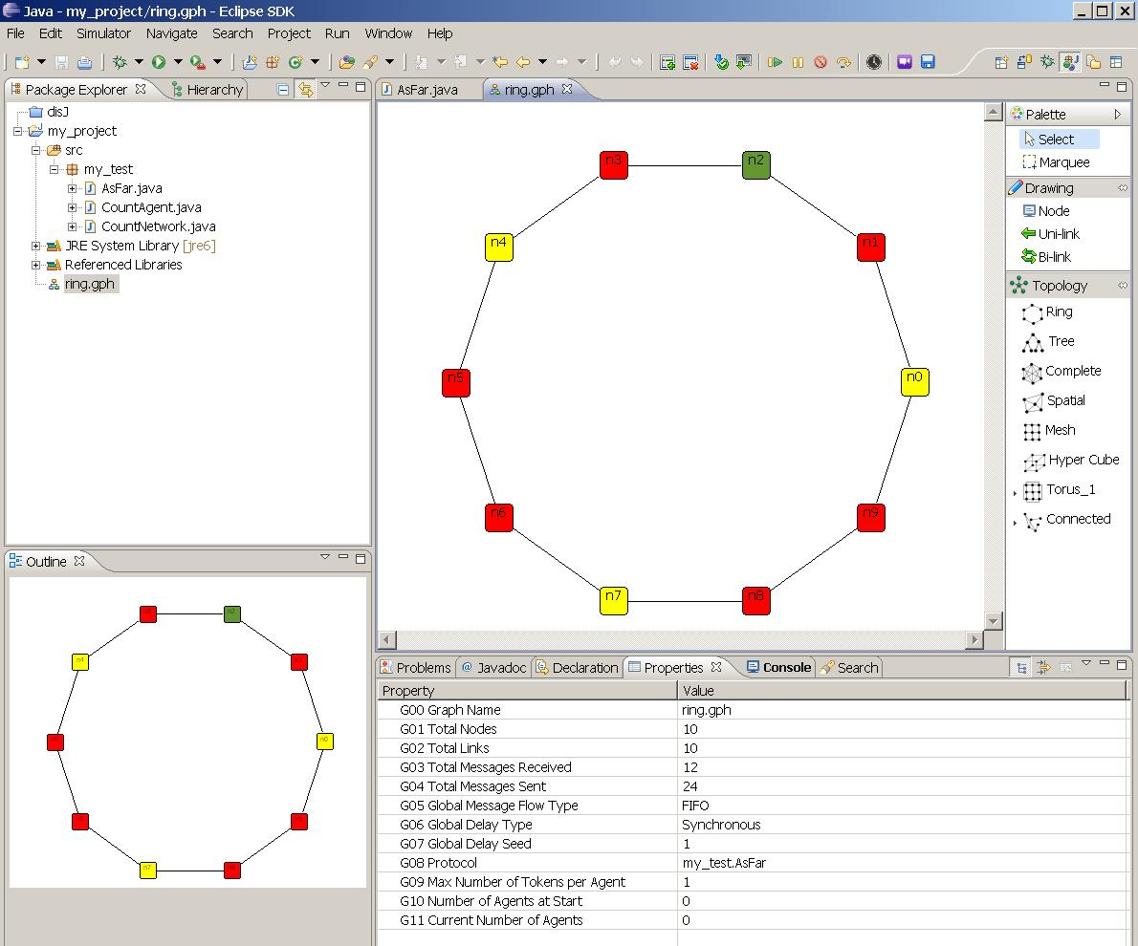

To view a node/link properties by selecting a node/link in editor at anytime of simulation execution

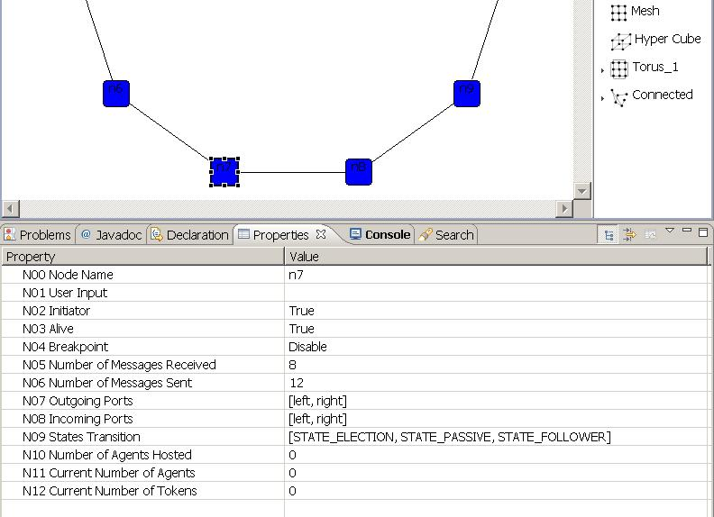

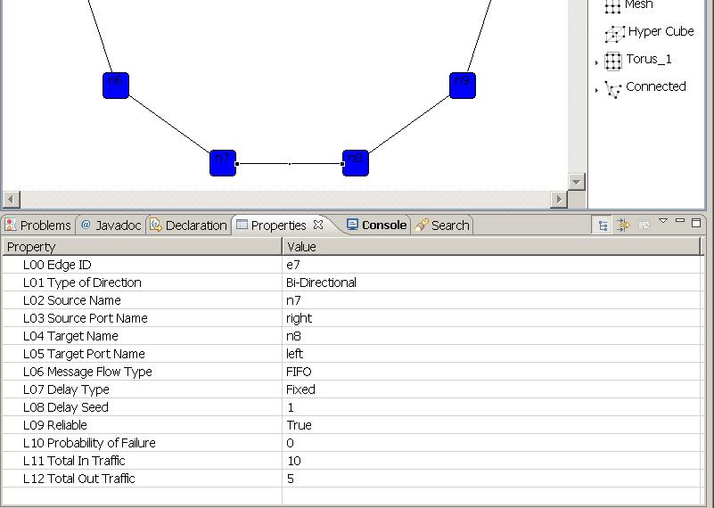

Chapter 6. Graphical and Statistics Reports

DisJ simulator provides basic information and statistic reports. Currently there are two types of reports, Java Console print out and DisJ View, which are not 100% done based on build milestone. However, it still provide some useful information for user to observe and analyze the simulating protocol. The following are snapshot of each type of reports

The Console output reports

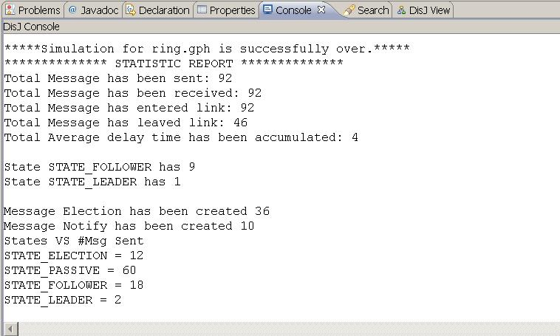

DisJ View reports

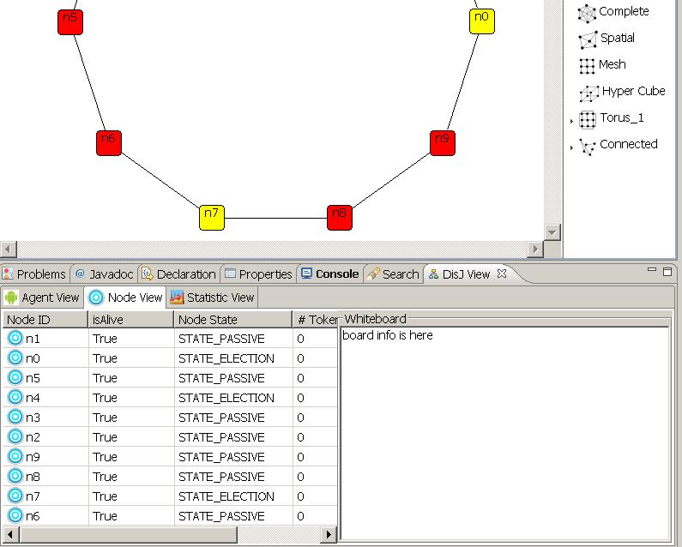

In order to open “DisJ View” in Eclipse is the same way of opening “Properties View” by go to menu and select Winder → Show View → Other… as shown below

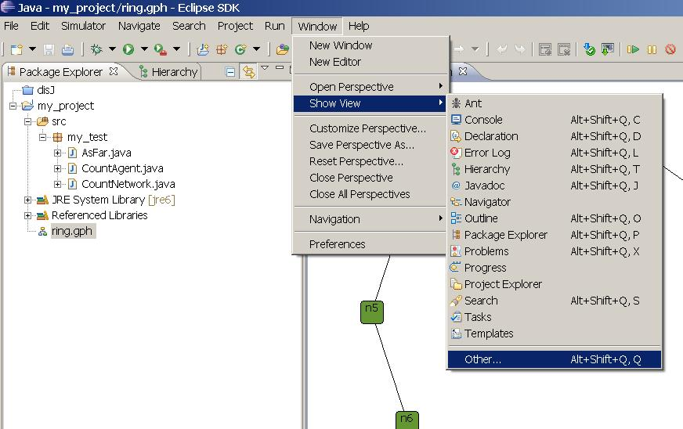

Once the Show View dialog pop up, select DisJ → DisJ View as shown below

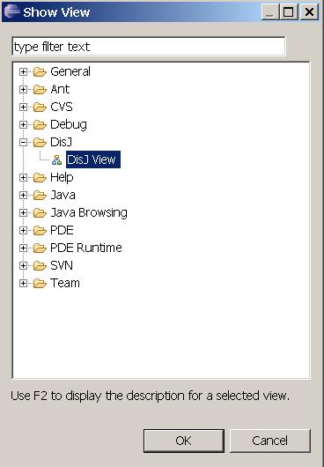

Chapter 7. Conclusion

DisJ is a lightweight tool for writing, test and simulate the reactive distributed algorithm in Java™. DisJ provides virtual processors in a given network topology (graph) with graphical interaction that allows user to view and debug the protocol. Also it ease user from setting up sophisticate infrastructure while preserve (almost) reality of distributed environment. Moreover, DisJ provides a nice Java™ Development Tool (JDT) from Eclipse™, which helps user in writing and debugging a complex protocol with Java™ language.

Appendix

The protocol is expressed as a set of rules of the form “state x event → action”, according to the reactive model defined in DADA.

In the convention used in DADA, rules are grouped by state, listing the difference “event → action” for that state.

Example 1:

A Protocol “As Far”, which elect a leader among the initiators in a bidirectional link Ring.

States: S = {ASLEEP, ELECTING, PASSIVE, FOLLOWER, LEADER}
S(init) = {ASLEEP}
S(terminate) = {FOLLOWER, LEADER}

Restrictions: RI U Bidirectional Ring

ASLEEP:
Spontaneously
begin
send (“Election”, id(x)) to all;
become ELECTING;
end

Receiving(“Election”, id)
begin
send (“Election”, id) to others;
become PASSIVE;
end

ELECTING
Receiving(“Election”, id)
begin
if id < min then
send(“Election”, id) to others;
become PASSIVE;

else if id = min from both directions then
send(“Notify”) to all;
become LEADER;

endif
end

PASSIVE
Receiving(“Election”, id)
begin
send (“Election”, id) to others;
end

Receiving(“Notify”)
begin
send(“Notify”) to others;
become FOLLOWER;
end

LEADER
Receiving(“Notify”)
begin
done election
end

In DisJ, the dual convention is used grouping the rules by event, listing the difference “state→action” for that event.

Example 2:

The same protocol from Example1, expressed using the dual convention.

States: S = {ASLEEP, ELECTING, PASSIVE, FOLLOWER, LEADER}
S(init) = {ASLEEP}
S(terminate) = {FOLLOWER, LEADER}

Restrictions: RI U Bidirectional Ring

SPONTANEOUSLY:
Asleep
begin
send (“Election”, id(x)) to all;
become ELECTING;
end

RECEIVING
Asleep (“Election”, id)
begin
send (“Election”, id) to others;
become PASSIVE;
end

Passive (“Election”, id)
begin
send (“Election”, id) to others;
end

Passive (“Notify”, msg)
begin
send (“Notify”, msg) to others;
become FOLLOWER
end

Electing (“Election”, id)
begin
if id < min
send(“Election”, id) to others;
become PASSIVE

else if id = min from both directions then
send(“Notify”) to all;
become LEADER;

endif
end

Leader(“Notify”)
begin
done election
end

Example 3:

The same protocol from Example2, expressed using Java Code.

package my_test;

import distributed.plugin.runtime.IMessage;
import distributed.plugin.runtime.engine.Entity;

/**
* Leader election protocol with multiple initiators, unique ID,
* synchronous and total reliable communication.
*
* The initiators (candidates) will send messages with its ID to all
* directions, and a message with smallest ID will kill every candidates
* and return back to the sender. A candidate with smaller ID will kill
* all arrival messages with bigger ID as well.
*/
public class AsFar extends Entity {

// all possible states
public static final int STATE_SLEEP = 0;
public static final int STATE_ELECTION = 1;
public static final int STATE_PASSIVE = 2;
public static final int STATE_FOLLOWER = 3;
public static final int STATE_LEADER = 4;

// all message label will be used in the protocol
private static final String MSG_LABEL_ELECTION = "Election";
private static final String MSG_LABEL_NOTIFY = "Notify";

// tracking that both of my messages have returned
private boolean leftMin;
private boolean rightMin;

/**
* Default constructor
*/
public AsFar() {
super(STATE_SLEEP);
}

public void init() {
String myId = this.getName();
this.become(STATE_ELECTION);
this.sendToAll(MSG_LABEL_ELECTION, myId);
}

@Override
public void alarmRing() {
// this protocol does not need this function
}

public void receive(String incomingPort, IMessage message) {

String msg = (String) message.getContent();
String msgLabel = message.getLabel();

if (this.getState() == STATE_SLEEP) {
this.become(STATE_PASSIVE);
this.sendToOthers(MSG_LABEL_ELECTION, msg);

} else if (this.getState() == STATE_PASSIVE) {
if (msgLabel.equals(MSG_LABEL_NOTIFY)) {
this.become(STATE_FOLLOWER);
this.sendToOthers(MSG_LABEL_NOTIFY, msg);

}else{
this.sendToOthers(MSG_LABEL_ELECTION, msg);
}

} else if (this.getState() == STATE_ELECTION) {
if (msgLabel.equals(MSG_LABEL_ELECTION)) {
this.electing(incomingPort, msg);
}else{
// should not happen!!
}

} else if (this.getState() == STATE_LEADER) {
if (msg.equals(MSG_LABEL_NOTIFY)){
System.out.println("Election completed: " + this.getName()
+ " is a leader");
}else{
// should not happen!!
}
}
}

/*
* Helping function that will compare a received ID with my ID
*/
private void electing(String incomingPort, String id) {

String myId = this.getName();

if (id.compareTo(myId) < 0) {
this.become(STATE_PASSIVE);
this.sendToOthers(MSG_LABEL_ELECTION, id);

} else if (id.compareTo(myId) == 0) {
// my election msg has returned
if (this.leftMin == true)
this.rightMin = true;
else
this.leftMin = true;

}
if (this.rightMin && this.leftMin) {
this.become(STATE_LEADER);

// send notify to one direction only
this.sendTo(MSG_LABEL_NOTIFY, incomingPort, "I " + myId + " is your leader");
}
}
}

